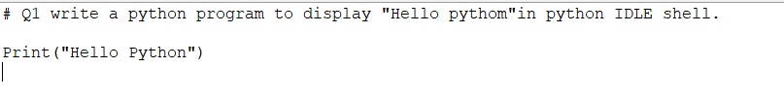



2. Write a python program to display hello python in window command prompt.



3. Write a python program to display “Hello Python” and “this our first class”Two different messages in one print statement only In both the python IDES.





4 & 5.





6.

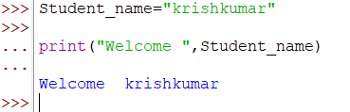

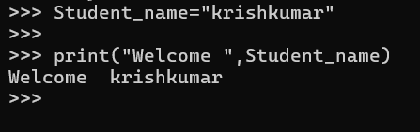

7.

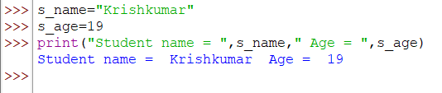

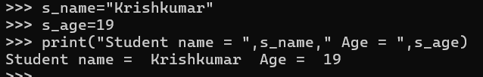

8.

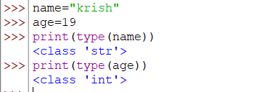

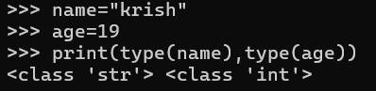

9.

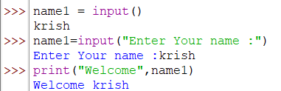

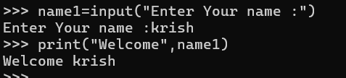

10.

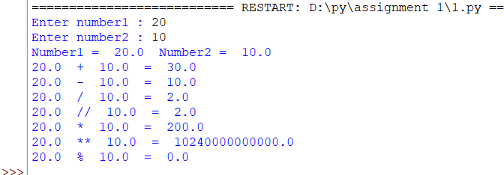

11.

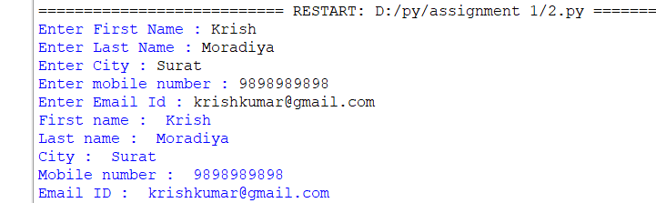

12.

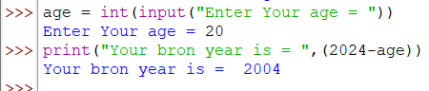

13.

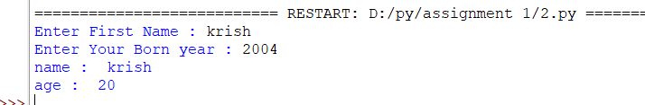

14.

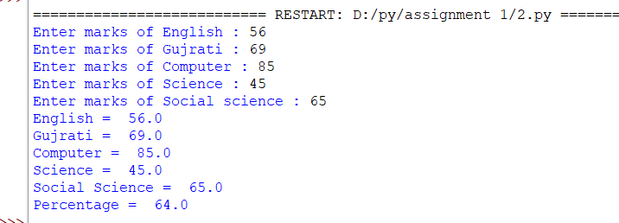

15.

